**Sindh:**

Kirthar Mountains

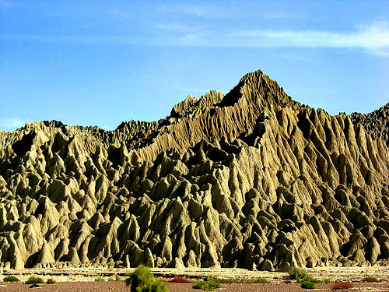

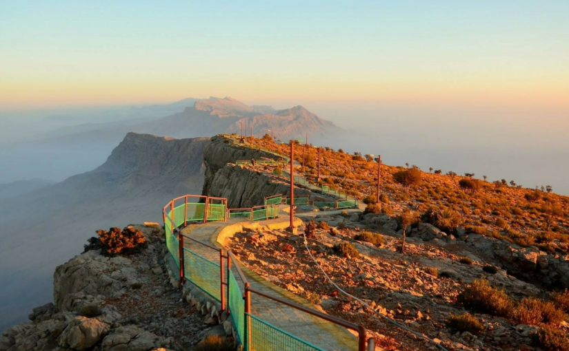

The **Kirthar Mountains** are a mountain range located in the Pakistani provinces of Balochistan and Sindh. The mountains extend southward for about 190mi (310km) from the Mula River in east-central Balochistan to Cape Monze on the Arabian Sea. The Kirthar Mountains form the boundary between the lower Indus Plain (to the east) and southern Balochistan (to the west). It consists of a series of parallel rock hill ridges rising from 4,000ft (1,200m) in the south to nearly 8,000ft (2,400m) in the north.